 | 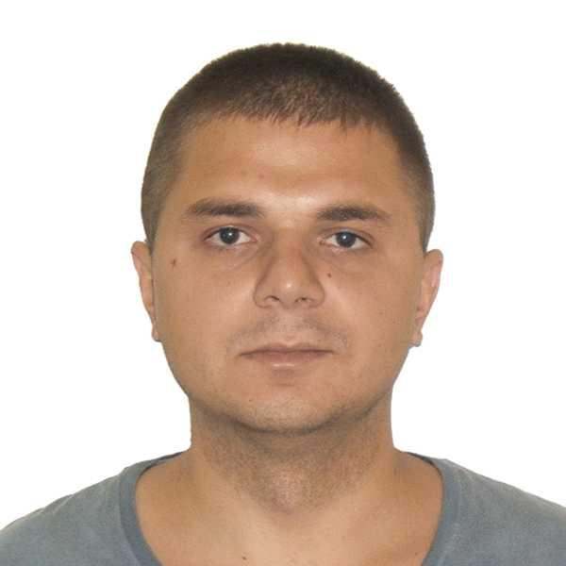
  SEAFARER'S APPLICATION FORM
  Position: | CHIEF OFFICER  or SECOND OFFICER | Readiness: | 27.11.2023
  Position: | CHIEF OFFICER  or SECOND OFFICER | Citizenship: | Ukraine
  Last name: | KIULAFLY | Marital status | married
  First name: | Petro | Children: | 1
  Middle name: |  | Nationality: | Ukrainian
  Birth date: | 26.09.1990 | Birth place: | Ukraine
  Home address: | Chisinau, Moldova | Phone mobile: | +380(63)8277145 WhatsApp, Telegram, Viber
  Home address: | Chisinau, Moldova | Phone mobile: | +373(78)837927 Mobile
  Home address: | Chisinau, Moldova | Email: | kiulafly@gmail.com
  English level: | Good | Marlins Test: | 85
  Spanish level: | Poor
  Russian level: | Fluently

Salary | Minimum: 260 | Expected: 300 | Last: 260 | €/day

Education
Educational institution | Speciality | Faculty | Place | Number | From | Till
NU "OMA" | Sea navigation | Navigation | Odessa/UKR | C16 086127 | 01.09.2012 | 30.06.2016
MCTF NU "OMA" | Dredging and navigation Technical Fleet | Navigation | Odessa/UKR | CK#39643626 | 31.07.2006 | 30.06.2012

Passports, Licenses & Certificates
Title | Class | Number | Place of issue | Issued | Valid
Passports & Visas
Seaman's book |  | AB687034 | Odessa, UKR | 24.12.2021 | 24.12.2026
Travel passport |  | FG923966 | Odessa, UKR | 12.07.2017 | 12.07.2027
Seaman's Book Panama |  | 500590385 | Panama, PAN | 01.11.2021 | 24.08.2024
USA Visa C1/D |  | N6708095 | Vilnius, LTU | 10.01.2019 | 08.01.2029
Canada Visa |  | E736494155 | London, GBR | 27.10.2022 | 05.06.2032
USA Visa B1/B2 |  | N6708096 | Vilnius, LTU | 10.01.2019 | 08.01.2029
Driving Licence |  | BXT 578810 | Odessa, UKR | 07.07.2016 | 07.07.2039
Diplomas & Endorsements
Certificate of Competency | Chief OffIcer | 03254/2019/08 | Odessa, UKR | 11.09.2019 | 01.01.2100
Certificate of Competency | Chief OffIcer | 03253/2019/08 | Odessa, UKR | 11.09.2019 | 01.01.2100
Dutch Endorsment | Chief OffIcer | 860012566/20079999 | Amsterdam, NLD | 29.10.2019 | 29.08.2024
GMDSS | General Operator | 03254/2019/08 | Odessa, UKR | 11.09.2019 | 01.01.2100
GMDSS Endorsement | General Operator | 03254/2019/08 | Odessa, UKR | 11.09.2019 | 29.08.2024
Panama Endorsement | Chief OffIcer | 203095977 | Panama, PAN | 11.11.2021 | 29.08.2024
UK Endorsment | Chief OffIcer | CEC8107420 | London, GBR | 10.06.2021 | 29.08.2024
Certificates & Licenses
Medical Care (VI/4.2) |  | 2193 | Odessa, UKR | 09.08.2019 | 09.08.2024
Proficiency in Survival Craft (VI/2) |  | 11879 | Odessa, UKR | 06.08.2019 | 06.08.2024
Medical First Aid (VI/4.1) |  | 9119 | Odessa, UKR | 08.08.2019 | 08.08.2024
Bridge Team and Resource Management (VIII/2) |  | 2297 | Odessa, UKR | 14.08.2019 | 14.08.2024
Basic Safety Training (VI/1.1-4) |  | 14356 | Odessa, UKR | 05.08.2019 | 05.08.2024
Dynamic Positioning Advanced Operator Course (DPA) |  | DPAV88/2523 | Naples, ITA | 06.10.2023 | 06.10.2027
Automatic Radar Plotting Aids (ARPA) |  | 2197 | Odessa, UKR | 12.08.2019 | 12.08.2024
Advanced Fire Fighting (VI/3) |  | 10585 | Odessa, UKR | 07.08.2019 | 07.08.2024
Ship Security Officer (VI/5) |  | 4382 | Odessa, UKR | 15.08.2019 | 15.08.2024
Electronic Chart Display and Information System (ECDIS) |  | 5255 | Odessa, UKR | 13.08.2019 | 13.08.2024
Leadership and Teamwork |  | 0165 | Odessa, UKR | 18.07.2017 | 01.01.2100
Dynamic Positioning Induction Operator Course (DPI) |  | 11/033/2020 | Odessa, UKR | 06.03.2020 | 06.03.2024
Dangerous and Hazardous Substances (V4,V5) |  | 0093/2020 | Odessa, UKR | 16.03.2020 | 16.03.2025
Wartsila SAM Electronics ECDIS |  | 166883 / 558930 | Odessa, UKR | 26.04.2020 | 01.01.2100
Working at Height Unit 4-Management & Supervisors |  | 20676-23 | Hull, GBR | 02.12.2022 | 02.12.2025
Working at Height Unit 3-Use of Rescue Equipment |  | 20676-17 | Hull, GBR | 01.12.2022 | 01.12.2024
Working at Height Unit 2-PPE User |  | 20676-1 | Hull, GBR | 29.11.2022 | 29.11.2025
PPE inspection Competent Person |  | 20676-29 | Hull, GBR | 03.12.2022 | 03.12.2025
Confined Space Trainig-Low Risk |  | 20738-75 | Hull, GBR | 19.01.2023 | 19.01.2026
Proficiency in Fast Rescue Boats |  | 309723 | Izmail, UKR | 18.10.2023 | 18.10.2028
HUET |  | 1/AH/0005/0/23 | Chornomorsk, UKR | 27.11.2023 | 27.11.2028
Medical Certificates
Yellow Fever Vaccination |  |  | Odessa, UKR | 05.02.2019 | 05.02.2029
Imovax Polio |  |  | Odessa, UKR | 27.07.2016 | 27.07.2026
OGUK Medical |  |  | Odessa, UKR | 15.09.2023 | 14.09.2025
COVID |  |  | Chisinau, MDA | 18.09.2023 | 17.09.2024

Sea-going experience
 | Vessel’s  name | Flag | Type | Engine | Rank | From | Shipowner
 | Vessel’s  name | Year | DWT | HP | Rank | Till | Crew Agency
1 | Ocean Geograph  (DP1) | PAN | Survey Ship | Caterpillar | Chief Officer | 17.07.2023 | Gardline Geosurvey Limited
1 | Ocean Geograph  (DP1) | 2007 | 1437 | 6920 | Chief Officer | 13.09.2023
2 | Ocean Geograph  (DP1) | PAN | Survey Ship | Caterpillar | Second Officer | 14.06.2023 | Gardline Geosurvey Limited
2 | Ocean Geograph  (DP1) | 2007 | 1437 | 6920 | Second Officer | 17.07.2023
3 | Ocean Reliance  (DP1) | PAN | Survey Ship | MAN-B&W | Second Officer | 25.10.2022 | Gardline Geosurvey Limited
3 | Ocean Reliance  (DP1) | 1987 | 2814 | 1700 | Second Officer | 25.02.2023
4 | Horizon Geodiscovery  (DP2) | PAN | Drilling Vessel | MAN | Second Officer | 27.10.2021 | Gardline Geosurvey Limited
4 | Horizon Geodiscovery  (DP2) | 2002 | 4100 | 6120 | Second Officer | 04.12.2021
5 | Ocean Endeavour | GBR | Survey Ship | Ruston | Second Officer | 29.07.2021 | Gardline Geosurvey Limited
5 | Ocean Endeavour | 1986 | 620 | 2984 | Second Officer | 23.09.2021
6 | Ocean Observer | GBR | Survey Ship | Ruston | Second Officer | 05.05.2021 | Gardline Geosurvey Limited
6 | Ocean Observer | 1987 | 1598 | 1720 | Second Officer | 30.06.2021
7 | Arklow Beach | NLD | General Cargo | MAK | Second Officer | 12.01.2021 | Arklow Shipping NL
7 | Arklow Beach |  | 8660 | 2665 | Second Officer | 02.04.2021 | Global Odessa / Sokur Ltd
8 | Arklow Bay | NLD | Dry Cargo | MAK | Second Officer | 17.06.2020 | Arklow Shipping NL
8 | Arklow Bay |  | 8660 | 2665 | Second Officer | 20.10.2020 | Global Odessa / Sokur Ltd
9 | EEMS DUISBURG  (DP2) | NLD | Heavy Load Carrier | SKANIA | Second Officer | 20.11.2019 | AMASUS SHIPPING B.V
9 | EEMS DUISBURG  (DP2) |  | 6000 | 3192 | Second Officer | 18.01.2020 | Global Odessa / Sokur Ltd
10 | GURES | PRT | Multi-Purpose Vessel | MAK | Second Officer | 08.02.2019 | AMAZSA Spain
10 | GURES |  | 7890 | 5149 | Second Officer | 12.07.2019 | Gretimybe
11 | EZARO | PRT | Multi-Purpose Vessel | MAK | Second Officer | 07.06.2018 | AMAZSA Spain
11 | EZARO |  | 7890 | 3840 | Second Officer | 25.10.2018 | Gretimybe
12 | GURES | PRT | Multi-Purpose Vessel | MAK | Second Officer | 24.07.2017 | AMAZSA Spain
12 | GURES |  | 7890 | 5149 | Second Officer | 01.02.2018 | Gretimybe

Crewing Agencies or Marine Companies
Crew Agency | City | Country | Contact Person | Phone
Gretimybe | Klaipeda | Lithuania |  | 370(46)380808
Global Odessa / Sokur Ltd | Odessa | Ukraine |  | 380(48)7253342

General Physical State
Height (cm) | Weight (kg) | Shoes | Clothes | Hair color | Eye color
185 | 85 | 43 | XL | brown | brown

Additional information

Date applied: | 24.11.2023 |  | Signature:

