APPLICATION FORM

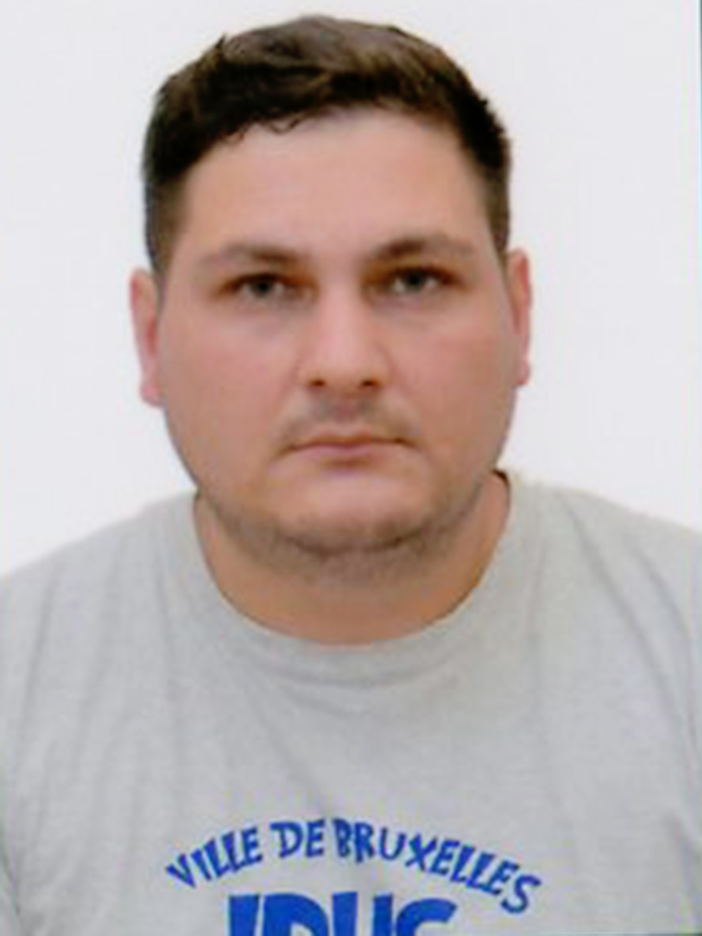

 |  |  |  |  |  | 1 | 0 | 3 | 3 | 4 | 0
Personal ID Number

Position Applied for: Electrician (III/6) | Date Available from: ANY TIME

1. Personal Data
Family Name: Daanov | First Name: Ruslan | Middle Name: Əlamzaroviç
Date of Birth: 11.05.1991 | Place of Birth: Kazakhstan/ Taraz | Citizenship: Kazakhstan
Permanent Address: Azerbaijan/ Sabunçu |  | Phone (Home): 055 375 32 76  Whatshapp +99455 3753276  E-mail: ruslandaanov@gmail.com

2. MaritimeEducation
Nameofschool | Town | Country | From | To | Type of degree or diploma
Azerbaijan State Marine Academy | Baku | Azerbaijan | 2009 | 2013 | Bachelor

3. ProfessionalTest
EnglishTest Date | Nameof Test | Score
Professional TestDate | Nameof Test | Score
Professional Interview Date | Result

4. FamilyDetails
Civil Status (Single, Married, Separated, Divorced, Widowed) : Single

Next of Kin (the first emergency contact) : | Relationship /Father
Address of Residence:  Azerbaijan/Celilabad | (055) 339 38 91

5. IdentityDocuments
Document | Country | Number | PlaceofIssue | IssueDate | ExpiryDate
Seaman'sBook | Azerbaijan | DQK 024307 | State Maritime Adminstration | 06.07.2023 | 06.07.2028
Travel Passport | Kazakhstan | N11139921 | Ministry of Internal Affairs | 10.04.2017 | 09.04.2027

6. ValidVisa
CountryorUnion | Type | ValidUntil

7. Courses Attended and Certificates Obtained
Document | Number | Dates |  | Place
Document | Number | Issue | Expiry | Place

CertificateofCompetency | RP-05860 | 25.05.2023 | 25.05.2033 | State Maritime Administration
MalteseEndorsementof COC
OilTankerEndorsement
ChemicalTankerEndorsement
GasTankerEndorsement
OilTankerFamiliarizationTraining
ChemicalTankerFamiliarizationTraining
GasTankerFamiliarizationTraining
OilTankersSpecializedTraining
ChemicalTankerSpecializedTraining
GasTankerSpecializedTraining
BasicTrainings | SO-2045-23 | 12.05.2023 | 05.05.2028 | State Maritime Administration
Proficiency in Survival Craft and Rescue Boats | SL-1515-23 | 11.05.2023 | 01.05.2028 | State Maritime Administration
AdvancedFireFighting
MedicalFirstAidTraining
Medical First Aid Training and Medical Care
GMDSS
GMDSS Endorsement
RadarObservation&Plotting
Automatic Radar Plotting Aids Simulator (ARPA)
BridgeTeamManagement
Shiphandling&Maneuvering
Ship Security-related familiarization security-awareness training | SI-1349-23 | 15.05.2023 | 10.05.2028 | State Maritime Administration
MalteseEndorsementof SSO
ISM Code | SP-1439-23 | 03.05.2023 | 03.05.2028 | State Maritime Administration
SafetyOfficer
ECDISTrainingCourse
RiskAssessmentCourse
C.O.W./ I.G.S
FirePracticeonTankers
VapourRecoverySystem
UnmannedMachinerySpace
FRAMO FamiliarizationCourse
Cargo Ballast Operations on Oil/Chemical Tankers
HazardousMaterials
Welder
Turner
Risk Management And Incident Investigation
Training of seafarers with designated security duties
Dangerous hazardous and harmfull cargoes | SH-1098-23 | 08.05.2023 | 08.05.2028 | State Maritime Administration
BasicTraining and qualifications on oil and chemical tanker cargo operations
Crowd management training

8. PhysicalData
Height | 173 sm
Weight | 90
ColourofHair | Black
ColourofEyes | Green
BoilersuitSize | XL
ShoesSize | 43

9. MedicalHistory | Yes | No
Have you ever signed off a ship due to medical reasons?
Did you undergo any medical operation in the past?
Have you consulted a doctor during the last 12 months for an illness/accident?
Do you have any health or disability problems now?

If yes, please give full details:

 | Passed: | Validtill:
International Medical Examination | 01.05.23 | 01.05.25
Vaccination Against YellowFiver
Vaccination Against Diphtheria

10. References (please give name and address of your current or past employer) | Officeremarks

NameofCompany
Name of person to contact
Address
Phone

NameofCompany
Name of person to contact
Address
Phone

11. Bank address forallotments
Beneficiary
AccountNo.
NameofBank
BankAddress

12. Knowledgeandexperience | Yes | No
OCIMF vetting experience:
ISGOT knowledge:

13. I hereby declare that the above, including Medical History, is true
Place

14. ForOfficeuseonly

