PERSONAL DETAILS
Family name |  | Abbasov |  |  | 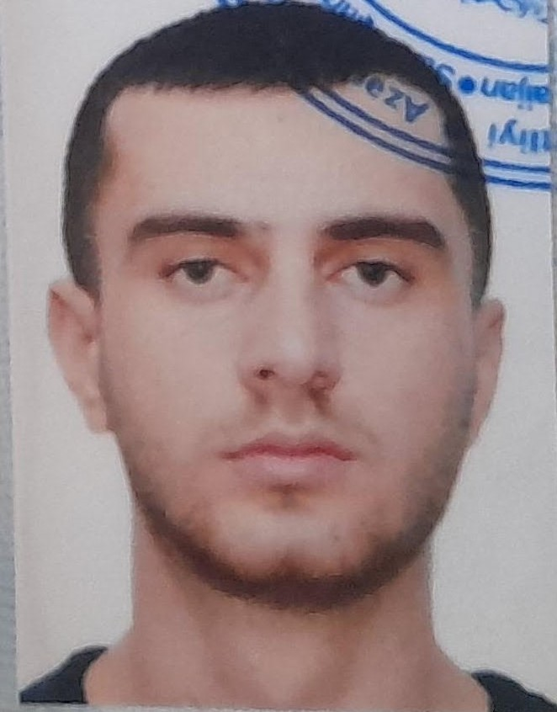
First name |  | Simur
Father’s name |  | Abdulgaffur
Date and place of birth |  | 05 January / Azerbaijan
Nationality |  | Azerbaijani
Marital status |  | -
Permanent address |  | Azerbaijan, Baku city
Nearest airport |  | Haydar Aliyev Airport/Baku, Azerbaijan
Height (sm) | Weight (kg) | Eyes color | Hair color | Size of safety shoes | Size of coveralls
182 | 75 | Green | Black | 42 | L (50)
CONTACT DETAILS
Mobile | E-mail address
+994 776008680 (+994 51 331 33 90) | simurabbasov2@gmail.com
NEXT OF KIN IN CASE OF EMERGENCY
Next of kin | Arabov Kamran | Relationship | Frıend
Address | Azerbaijan, Baku, Yeni Yasamal
Mobile phone | +994 559131722
TRAVEL PASSPORT DETAILS
Document | Number | Place of Issue | Issued | Valid
National Travelling Passport | C 01490658 | Ministry of Internal Affairs of Azerbaijan Republic | 27.10.2017 | 26.10.2027
COMPUTER SKILLS
Windows | Microsoft Office | Internet
Excellent | Average | Excellent
EDUCATION
Full name of School | Place of Issue | Grade/Class | From | To
Azerbaijan State Marrıot Kollec | Azerbaijan, Baku | Electro-technıcal ratıng | 2016 | 2020
KNOWLEDGE OF LANGUAGES
Languages | Speaking | Reading | Writing
Azerbaijan | native | native | native
Turkish | excellent | excellent | excellent
English | fluency | fluency | fluency
Russian | fluency | fluency | fluency
MEDICAL INFORMATION
Document | Grade | Place of issue | Last exam | Next exam
Seaman’s Medical Certificate | Health Certificate | Azerbaijan State Maritime Agency | 26.11.2020 | 26.11.2022
STCW AND OTHER CERTIFICATES
Name of course/Certificate | Institute | Place | Date of issue | Cert. No | Date of expiry
Seaman's record book | STCW | Republic of Azerbaijan State Maritime Administration | 04.03.2022 | DQK 019415 | 04.03.2027
Seafarers identity document | STCW | Republic of Azerbaijan State Maritime Administration | 04.03.2022 | AZE024330 | 04.03.2027
Electro-technıcal ratıng | STCW | Azerbaijan | 21.02.2022 | № RP- 10938 | --
Internatıonal Safety Management Code | STCW | Azerbaijan | 23.12.2021 | № SP-1239-20 | 18.12.2025
(STCW-78, A-VI/ 1-1/ 1-2/ 1-3/ 1-4) | STCW | Azerbaijan | 25.05.2021 | № SO-0942-21 | 26.04.2026
Proficiency in survival craft and boats other than fast rescue boats | STCW | Azerbaijan | 14.12.2020 | №SL 1257-20 | 01.12.2025
Training for seafarers with designated security duties | STCW | Azerbaijan | 23.12.2020 | № SH- 0793-20 | 23.12.2025
Ship Security-related familiarization security-awareness training | STCW | Azerbaijan | 11.01.2021 | № SI- 0010-21 | 28.12.2025
SEA EXPERIENCE (MOST RECENT EXPERIENCE ON TOP LINE)
Vessel | Company | Type of vessel | Flag | Rank | Sign on | Sign off
“SABIT ORUDJOV” | ASCO | Passenger | Azerbaıjan | Electrician | 03.02.2020 | 03.05.2020
“VOLODYMYR VOROBYOV” | VI-ZA Star | General Cargo | St.Kitts Nevis | Electrician | 20.03.2022 | 20.10.2022

