CREW APPLICATION

PERSONAL INFORMATIONS
Name & Surname | Aziz Aghamaliyev |  |  |  | 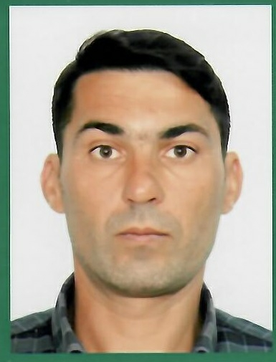
Nationality | Azerbaycan
D.O.B | 15.07.1982
English | Beginner
Russian | Advanced
Marital Status | Single | Married |  | Divorced
Number Of Children | 3
Height & Weight | 169 sm & 70 kg
Suit & Shoes Size | M & 42
Mobile Number | +994557219755  +994509728040 |  | Local Number
Email Address | dcagaziz@yandex.ru
Residence Address | Baki city, Pirallahi district, Pirallahi island home 10

Requested Rank | 3rd mate; 2nd mate | Availability Date
Prefer Vessel Types | Oil Tanker, General Cargo | Required Salary
Graduated School | Астраханский Университет Морского и Речьного Транспорта

SEAMAN’S BOOK & PASSPORT INFORMATIONS
Seaman’s Book No | DQK020885
Seaman’s Book Validity | 02.08. 2027
Passport Number | C03138203
Passport Validity / | 01.03.2030

,

CERTIFICATION

Competency |  | Validity

Certificate Name | Expiry Dates /
STCW – 78 | 25.06.2026
Proficiency in survival craft and boats other than fast rescue boat | 07.07.2026
International Safety Management | 14.09.2026
Advanced training for Oil Tanker Cargo Operations | 13.04.2027
Ship Security-related familiarization security-awareness training | 24.04 2027
Training for seafarers with designated security duties | 24.04.2027
Training in Advanced fire-fighting | 04.12.2025
Proficiency in Fast Rescue Boats | 11.02.2026
Radar, ARPA, Bridge Teamwork and Search and Rescue | 25.11.2025
Ship Handling and Maneuvering | 20.04.2027
Dangerous, Hazardous and Harmful Cargoes | 26.04.2027
Bridge Resource Management | 11.02.2027
Leadership and Teamwork | 01.03.2027
Medical First Aid | 25.05.2023
Able Seafarer Deck | Unlimited
Daughter-craft Coxswain (Scotland Aberdeen – Petrofac Training Service) | Unlimited
GMDSS | 23.05.2027
Operational Use of Electronic Chart Display and Information Systems (ECDIS) | 19.05.2027

LAST 5 COMPANIES EMPLOYED

Ship Name | DWT | Ship Type | Sign on & Sign Off Dates | Rank
MPK-474 | 280 | Passenger | 2005-2007 | AB
Baki | 1354 | ERRV | 2007-2010 | AB
Nefteqaz 58 | 2723 | AHTS/PSV | 2007-2010 | AB
Aviva. Roro | 5630 | Roro | 2022- | AB
Caspian Qala | 2300 | PSV | 2007-2010 | FRC Coxswain
Barra |  | ERRV | 2007-2010 | FRC Coxswain
Caspian Protector | 2108 | ERRV | 2010 - 2022 | DC Coxswain

