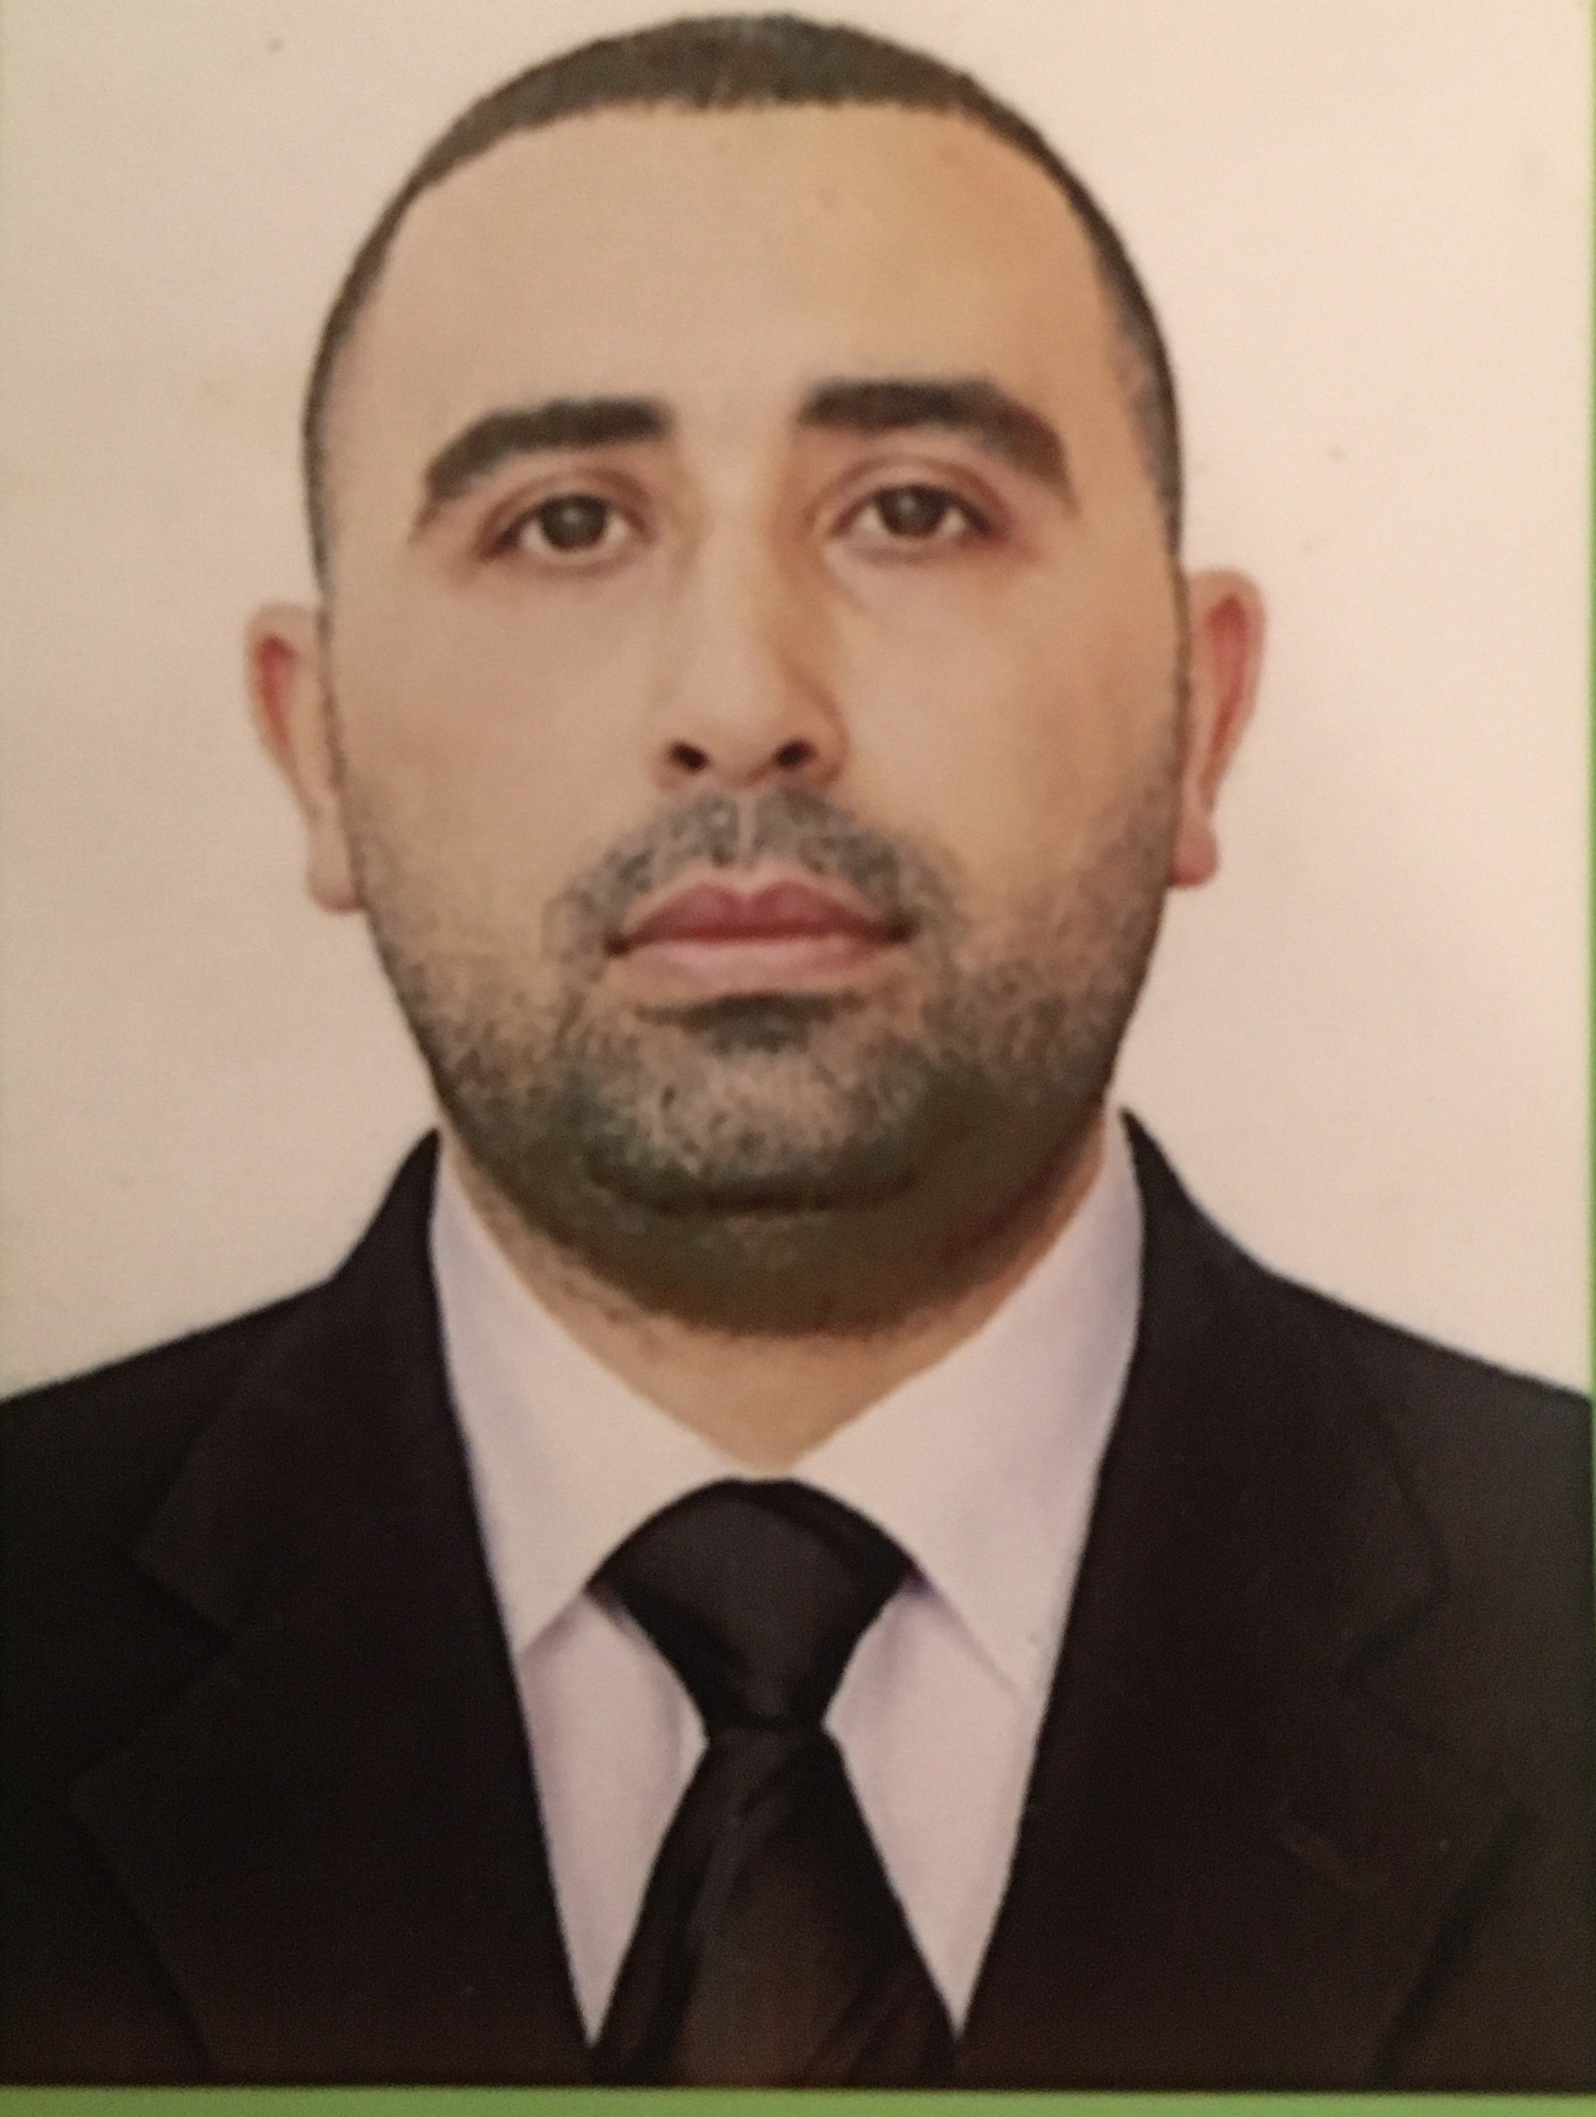

APPLICATION FORM

ABLE SEAFARER DECK | Date Available from:

1. Personal Data
Family Name: Hasanov | First Name: Zaur | Patronymic:Nariman
Permanent Address: Baku city, Khazar region Lev Starchuk str 4-13 |  | Phone (Mobile):  Phone (Mobile)  E-mail:zaur_hesenov_2019@mail.ru

2. Maritime Education
Name of school | Town | Country | From | To | Type of degree or diploma
Kainat Marine College | Baku | Azerbaijan | 04.12.2018 | 18.06.2019 | AB Sailor

3. Language knowledge
English | Average
Russian | Very well
Azerbaijan | Very well

4. Family Details
Civil Status(Single, Married, Separated, Divorced, Widowed) : Married
Relationship: Brother

5. Identity Documents
Document | Country | Number | Place of Issue | Issue Date | Expiry Date
Seaman's Book | Azerbaijan | DQK013881 | State of maritime administration | 30.03.2019 | 30.03.2024
Travel Passport | Azerbaijan | C03002484 | Ministry of internal affairs | 25.08.2021 | 24.08.2031
Civil Passport | Azerbaijan | 15436874 | Xazar RPI | 14.09.2015 | 29.09.2023

6. Courses Attended and Certificates Obtained
Document | Number | Dates |  | Place
Document | Number | Issue | Expiry | Place

Certificate of Competency | 0903/19 | 16.08.2019 | 16.08.2024 | AZERBAIJAN
Maltese Endorsement of COC
Oil Tanker Endorsement
Chemical Tanker Endorsement
Gas Tanker Endorsement
Oil Tanker Familiarization Training
Chemical Tanker Familiarization Training
Gas Tanker Familiarization Training
Oil Tankers Specialized Training
Chemical Tanker Specialized Training
Gas Tanker Specialized Training
Basic Trainings | SO-1905-19 | 26.07.2019 | 25.07.2024 | AZERBAIJAN
Proficiency in Survival Craft and Rescue Boats | SL-0953-19 | 29.07.2019 | 25.07.2024 | AZERBAIJAN
Advanced Fire Fighting
Medical First Aid Training
Medical First Aid Training and Medical Care
GMDSS
GMDSS Endorsement
Radar Observation & Plotting
Automatic Radar Plotting Aids Simulator (ARPA)
Bridge Team Management
Shiphandling & Maneuvering
Ship Security Officer Training Course | SI-1895-19 | 25.07.2019 | 17.07.2024 | AZERBAIJAN
Maltese Endorsement of SSO
ISM Code | SP-1097-19 | 22.07.2019 | 22.07.2024 | AZERBAIJAN
Safety Officer
ECDISTraining Course
Risk Assessment Course
C.O.W./ I.G.S
Fire Practice on Tankers
Vapour Recovery System
Unmanned Machinery Space
FRAMO Familiarization Course
Cargo Ballast Operations on Oil/Chemical Tankers
Hazardous Materials
Welder
Turner
Risk Management And Incident Investigation
Training of seafarers with designated security duties in compliance with ISPS Code | SH-1071-19 | 22.07.2019 | 19.07.2024 | AZERBAIJAN
Seafarers Medical Certificate | 033847 | 01.03.2019 | 01.03.2020 | AZERBAIJAN

7. Physical Data
Height | 178
Weight | 95
Colour of Hair | Brown
Colour of Eyes | Brown
Boilersuit Size | XL
Shoes Size | 42

8. Medical History | Yes | No
Have you ever signed off a ship due to medical reasons? |  | x
Did you undergo any medical operation in the past? |  | x
Have you consulted a doctor during the last 12 months for an illness/accident? |  | x
Do you have any health or disability problems now? |  | x

9. References (please give name and address of your current or past employer) | Office remarks

Name of Company
Name of person to contact
Address
Phone

Name of Company
Name of person to contact
Address
Phone

10. Bank address for allotments
Beneficiary
Account No.
Name of Bank
Bank Address

11. Seagoing Experience
Name of vessel | Flag | Vessel’s Type | DWT | Manager or Owner | Rank | From d/m/y | To  d/m/y
Amiral | Tanzania | Roro | 4000 |  | Matros | 07.11.2021 | 26.01.2022
Volodymyr Vorobyov | St Kitts and Nevis | G.Gargo | 3346 |  | Matros | 05.020.2022 | 18.07.2022

