CV  ZAUR GURBANOV  2nd engineer  zaur.gurbanov.89@gmail.com  +994(55)244-02-42 |  |  |  | 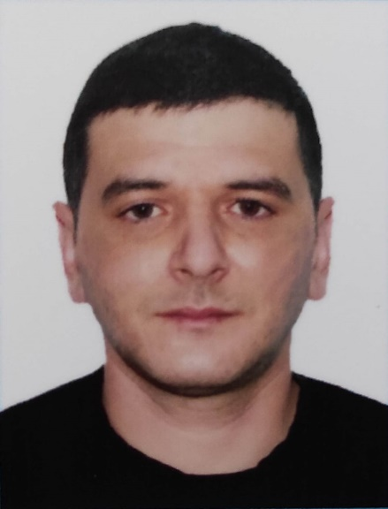
Main information
Position: | 2ndengineer | Desired Type of Ship: | Any
Desired salary: | 4000 USD | Available from: | ASAP
Full Name: | Zaur Gurbanov | Date of birth: | 16.07.1989
Citizenship: | Azerbaijan | Place of birth: | Shevchenko, Kazakhstan
Phones: | +994(55)244-02-42 | Country of residence: | Azerbaijan
E-mail address: | zaur.gurbanov.89@gmail.com | City/ Address: | Baku, Surakhani district, New Guneshli settle.,
Skype: | - | Nearest airport | Baku, AZ
English level:  Russian level: | Good  Good | Schengen visa valid up: | NIL

Passports / Smbk | # | Date of issue | Date of expire | Place of issue
Seaman's book | AZE021908 | 23.01.21 | 23.01.26 | State Maritime Agency, Baku AZE
International passport | C02781497 | 20.08.2019 | 19.08.2029 | Ministry of Internal Affairs AZE
Diplomas | # | Date of issue | Valid up | Place of issue
Rank | Second engineer officer
Professional license | 001057/17 | 08.11.2017 | 08.11.2026 | Baku. AZE
Endorsement | 000708/21 | 10.11.2021 | 10.11.2026 | Baku. AZE
Certificates | # | Date of issue | Valid up | Place of issue
Proficiency in Survival craft and boats other than fast rescue boats | SL-1156-20 | 24.11.2020 | 24.11.2025 | Baku. AZE
International Safety Management Code | SP-1255-20 | 29.12.2020 | 29.12.2025 | Baku. AZE
 | SO-1648-20 | 08.12.2020 | 08.12.2025 | Baku. AZE
Engine resource management | ER-0307-20 | 18.12.2020 | 18.12.2025 | Baku. AZE
Leadership and Teamwork | DL-0498-20 | 03.06.2021 | 03.06.2026 | Baku. AZE
Crowd management training | SC-0170-18 | 24.05.2018 | 24.05.2023 | Baku. AZE
Safe operation and maintenance of high voltage systems 1000 volts or more | DM-0161-17 | 31.05.2017 | 31.05.2022 | Baku. AZE
Medical First aid | SN-0773-19 | 08.11.2019 | 08.11.2024 | Baku. AZE
Dangerous , hazardous and harmful cargoes | SK-0224-18 | 01.05.2018 | 01.05.2023 | Baku. AZE
Training in advanced fire - fighting | SJ-0586-18 | 11.05.2018 | 11.05.2023 | Baku. AZE
Training for seafarers with designated security duties | SH-0798-20 | 23.12.2020 | 23.12.2025 | Baku. AZE
Ship Security - related training and instruction | SI-2197-19 | 20.09.2019 | 20.09.2024 | Baku. AZE
Basic training and qualifications on oil and chemical tanker cargo operations | SA-0201-18 | 11.06.2018 | 08.06.2023 | Baku. AZE
Advanced training for chemical tanker cargo operations | AS-0026-20 | 11.12.2020 | 11.12.2025 | Baku. AZE
Advanced training for oil tanker cargo operations | SB-0098-18 | 30.05.2018 | 30.05.2023 | Baku. AZE

Medicine | # | Date of issue | Valid up | Place of issue
Medical fitness certificate: | Unical-A LLC | 16.11.2021 | 16.11.2023 | Baku. MMC
Alco-drug certificate: | Unical-A LLC | 16.11.2021 | 16.11.2023 | Baku. MMC
Yellow fever: | NIL

Additional info
Education: Bachelor  (Azerbaijan State Marine Academy) |  | Knowledge of other languages:  Russian, Turkish, English
Specialty: Ship energetic equipment’s and their exploitation |  | Computer skills: Windows, MS Office, Photoshop, Corel Draw, 3dmax
Second (relative) specialty: |  | Welding skills: NIL
Next of Kin
Next of kin: Brother |  | Phone: +994(55)2682944
Name, Surname: Elnur Gurbanov |  | Address: Azerbaijan Republic, Baku, Surakhani, new Guneshli
Biometricaldata
Sex: Male | Height: 178 |  | Overall size:52
Eyes color: brown | Weight:85 |  | Shoe size:42

